P250/2

**(WORLD PROBLEMS AND DEVELOPMENT)**

**PAPER 2**

JULY/AUGUST 2016

3HRS

WESTERN JOINT MOCK EXAMONATIONS

Uganda Advanced Certificate of Education

**GEOGRAPHY**

**PAPER 2**

3HOURS

**INSTRUCTIONS TO CANDIDATES**:

* Answer **four** questions in all
* Section **A** is compulsory.
* Answer **three** questions from section **B**.
* Credit will be given for use of relevant sketch maps, diagrams and specific examples.
* Any additional question(s) answered will not be marked.

**SECTION A**

1. Study the table provided below showing land area and population size for selected African countries and answer the questions that follow.

|  |  |  |
| --- | --- | --- |
| Country | Land area (‘000s cm2) | Population size(‘000s) |
| Algeria | 2,382 | 30,800 |
| Central African Republic | 623 | 3,800 |
| Chad | 1,259 | 7,900 |
| Djibouti | 23 | 600 |
| Egypt | 995 | 65,200 |
| Ethiopia | 1,000 | 65,800 |
| Libya | 1,760 | 5,400 |
| Morocco | 446 | 29,200 |
| Niger | 1,267 | 11,200 |
| Somalia | 627 | 9,100 |
| Sudan | 2,376 | 31,700 |
| Tunisia | 155 | 9,700 |

[*Adopted: 2003 African development indicators: World Bank, Washington DC P5*]

(a) Calculate the population density for each of the selected countries shown in the table **6mks**

(b) Using the base map provided, draw a choropleth (density) map to represent the information obtained. In (a) above. **9mks**

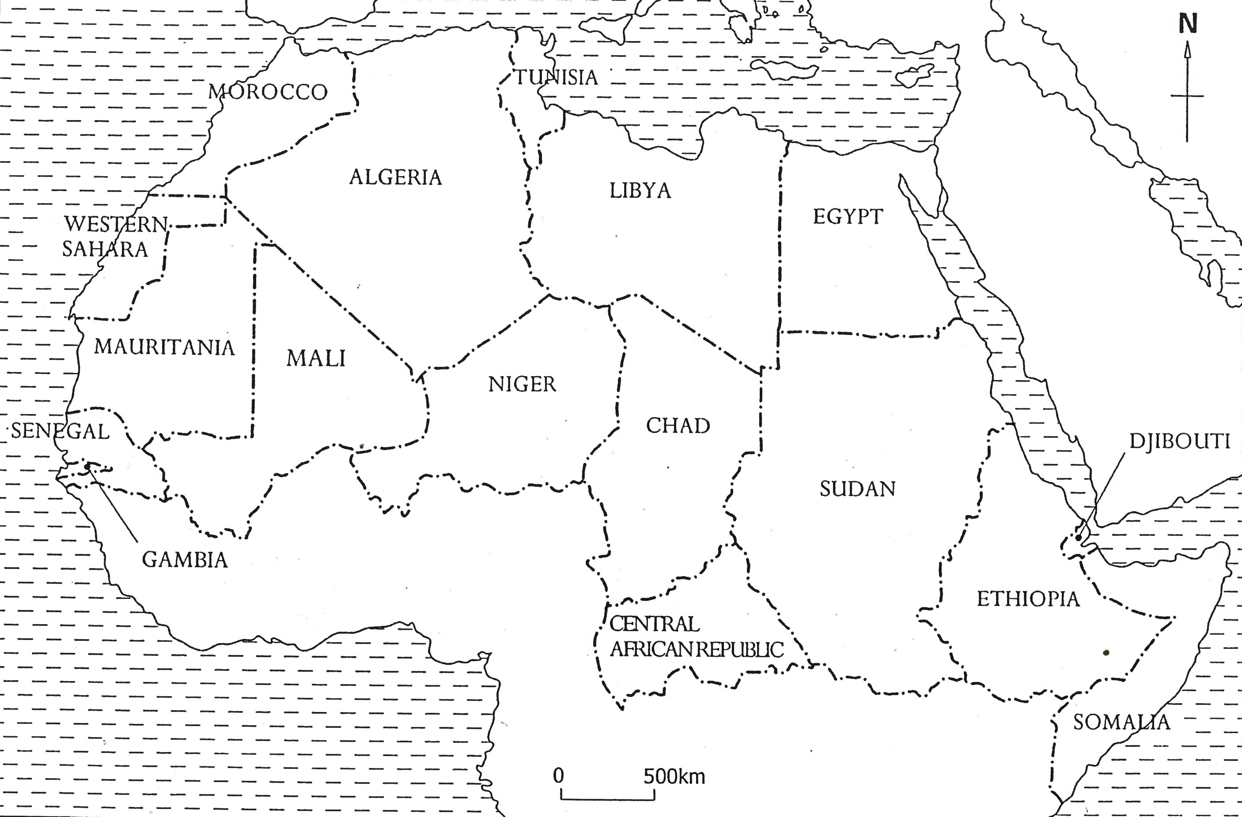

(c) Outline the merits and demerits of using the statistical method used in (b) above.

**5mks**

(d) Explain the causes of the variations in the population density of the region shown on the base map. **5mks**

**SECTION B**

2 (a) Describe the characteristics of Agricultural communes in China. **8mks**

(b) Asses the contribution of Agricultural communes to the development of China.

**17mks**

3 (a) Account for the destruction of forests in tropical Africa. **15mks**

(b) Outline the effects of deforestation on the environment in tropical Africa. **10mks**

4. To what extent have the physical factors favoured the development of fishing industry in either Namibia or Japan. **25mks**

5. Examine the factors limiting the development of mining industry in either Zambia or Democratic Republic Congo. **25mks**

6. Examine the factors limiting effective utilization of inland water transport in Africa.

**25mks**

7. Examine the problems faced by the tourism industry in either Egypt or Kenya**. 25mks**

8.Examine the causes and effects of desertification in either Namibia or California in U.S.A **25mks**